## Admin login with valid details

Expected Result: Admin is directed to dashboard

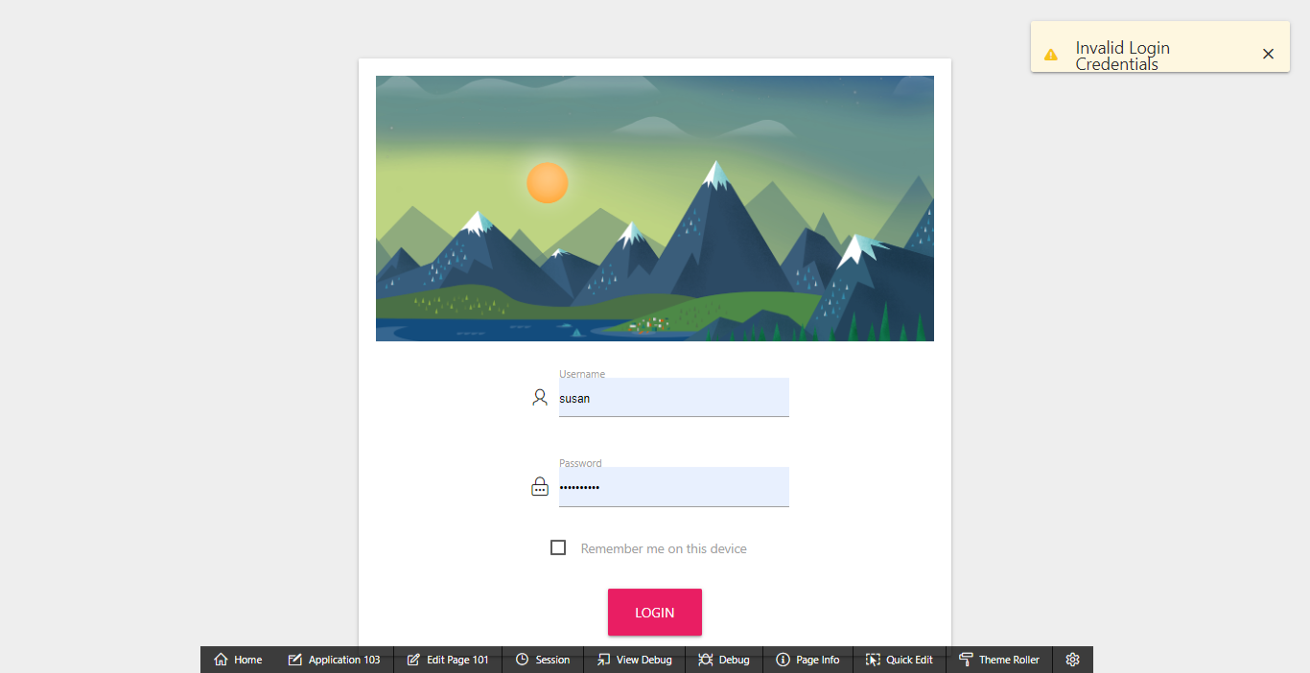

## Admin login with invalid details

Expected Result: Error message is displayed, and login is disallowed

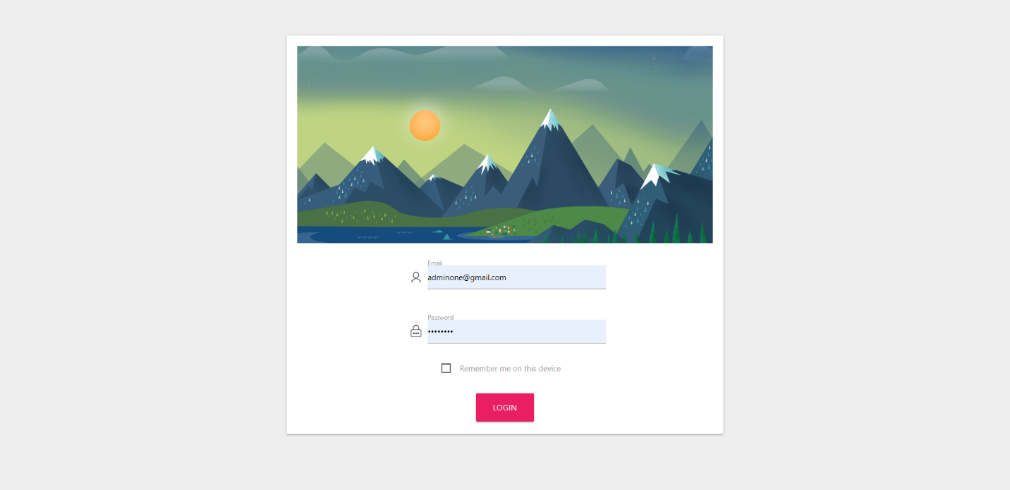

## View dashboard

Expected Result: A dashboard is shown showing summary of details

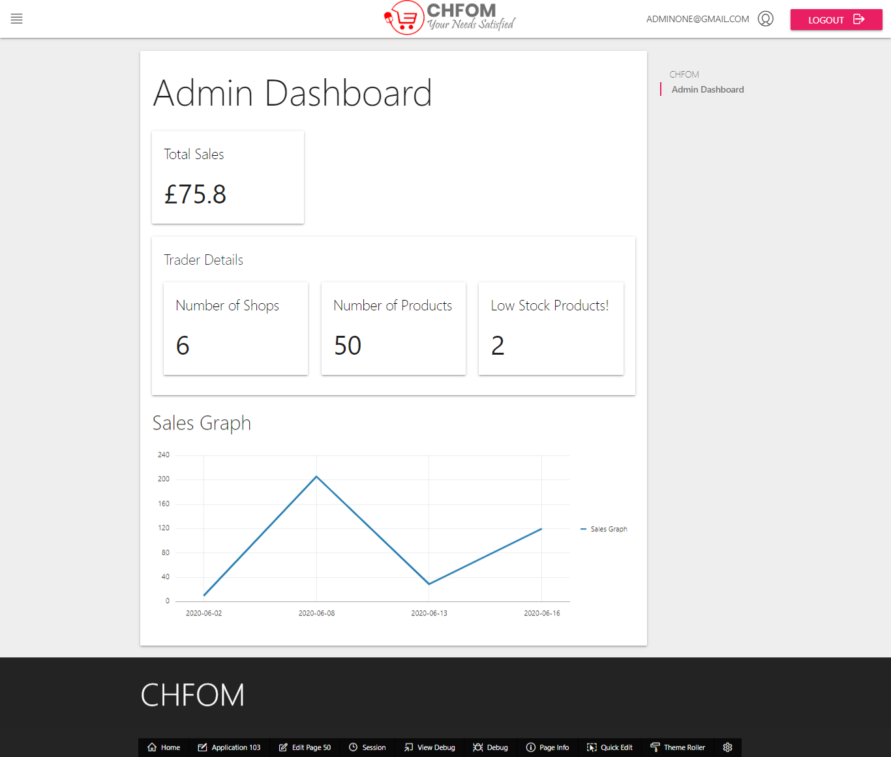

## View Customer

Expected Result: Admin can view customer information and related information

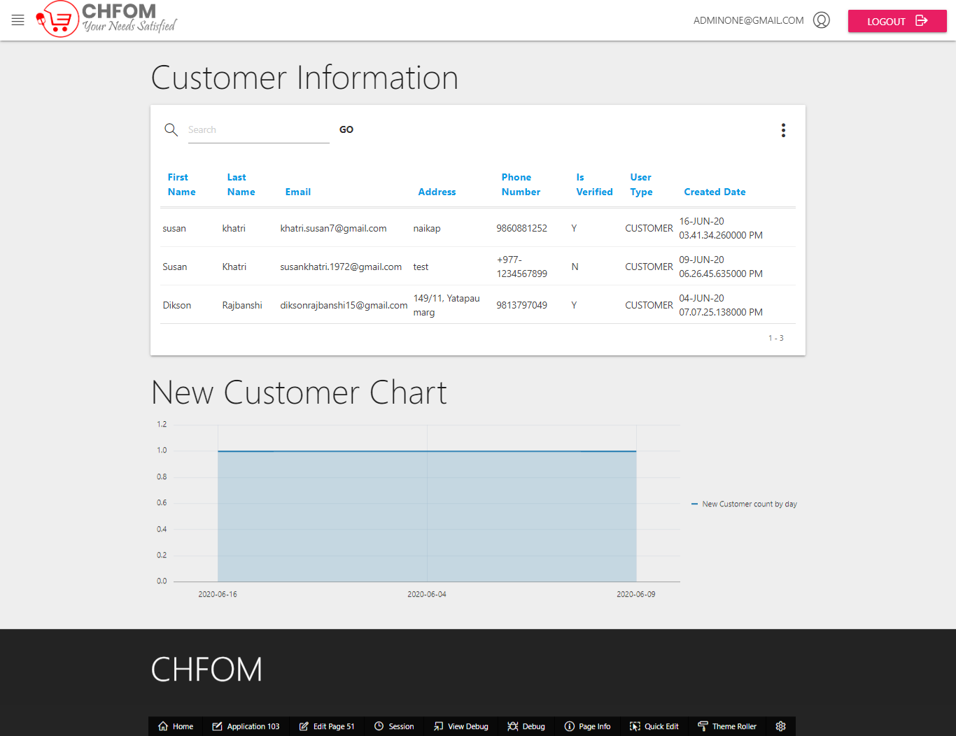

## An admin is able to view traders with their shops and products

Expected Result: A report with trader details, shops and products is shown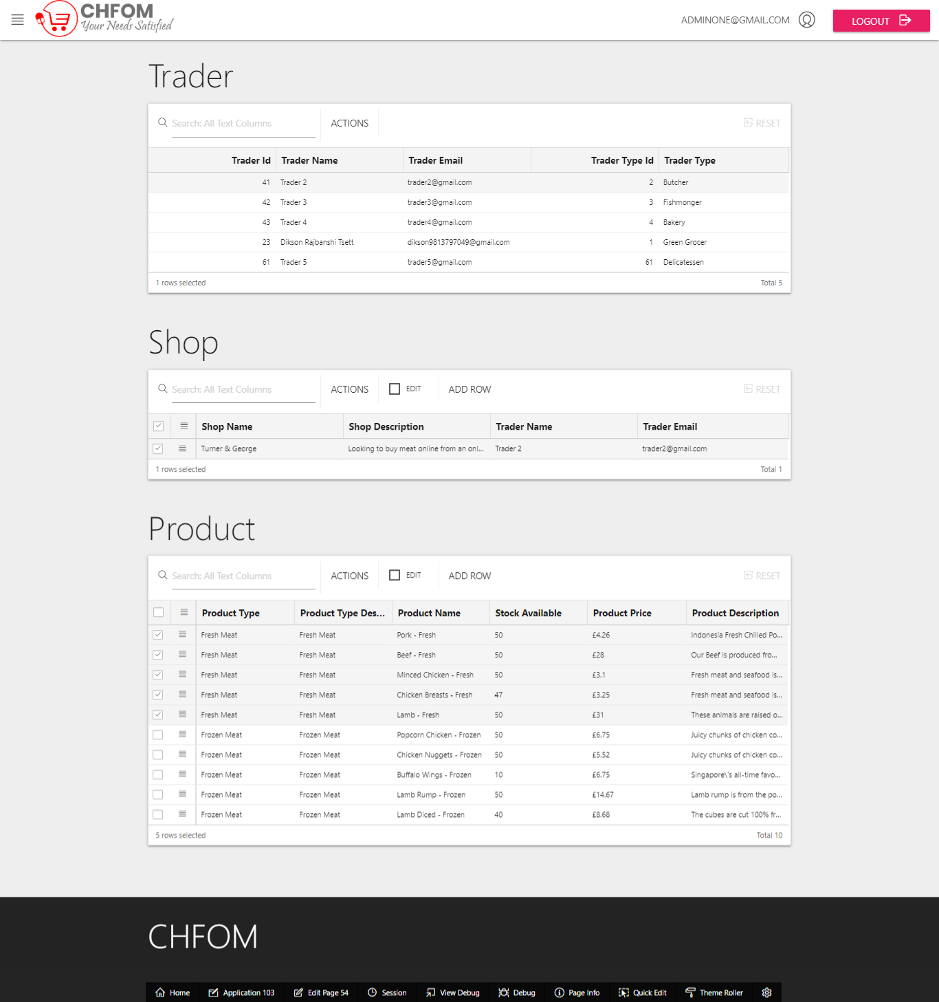

## View product reviews from customer

Expected Result: List of reviews is shown product-wise

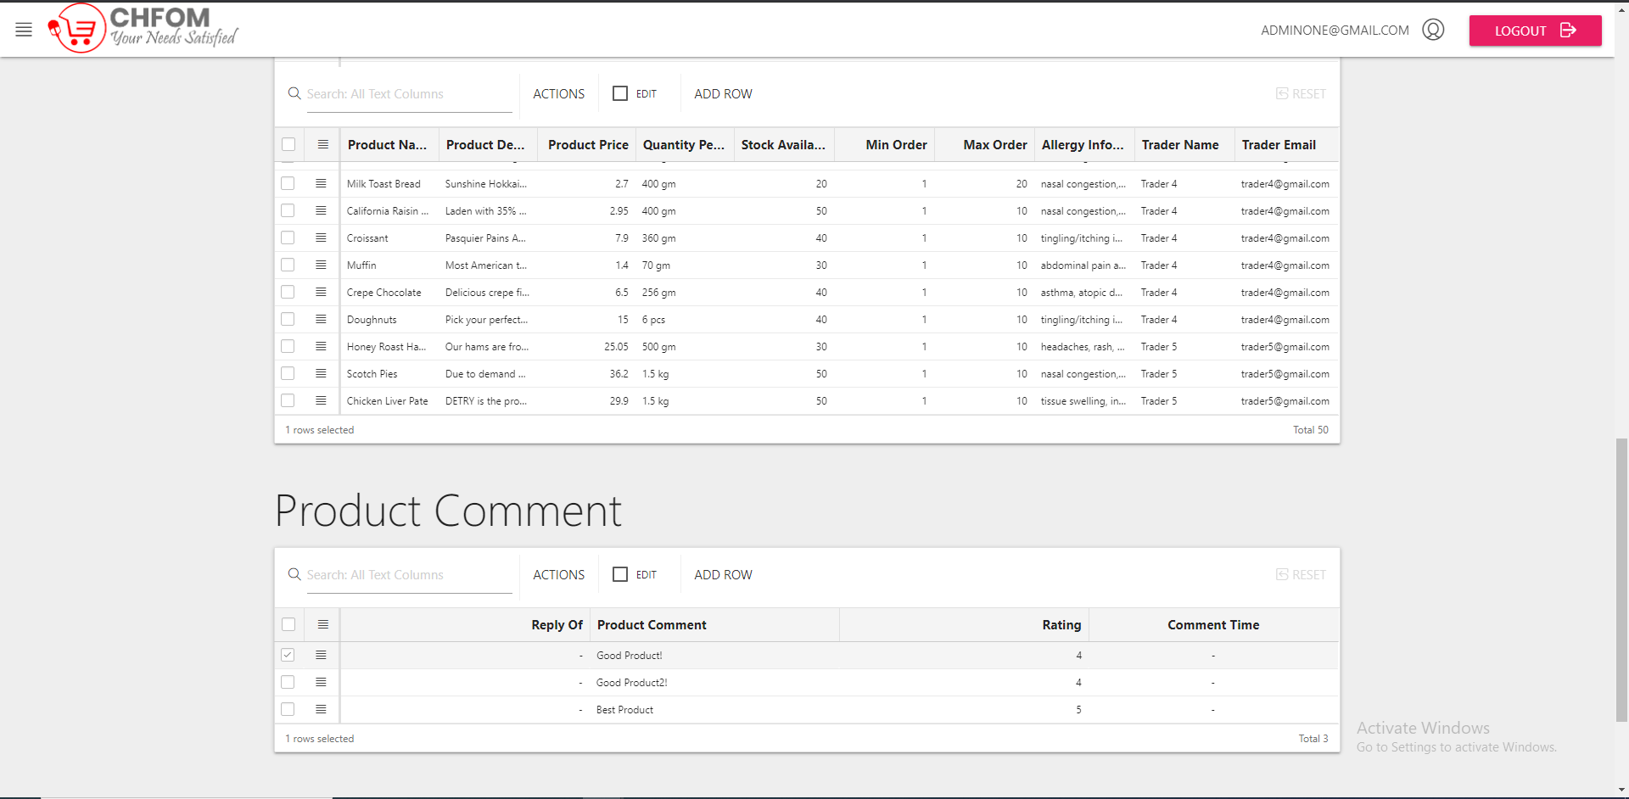

## View Transaction

Expected Result: The list of transaction done can be viewed

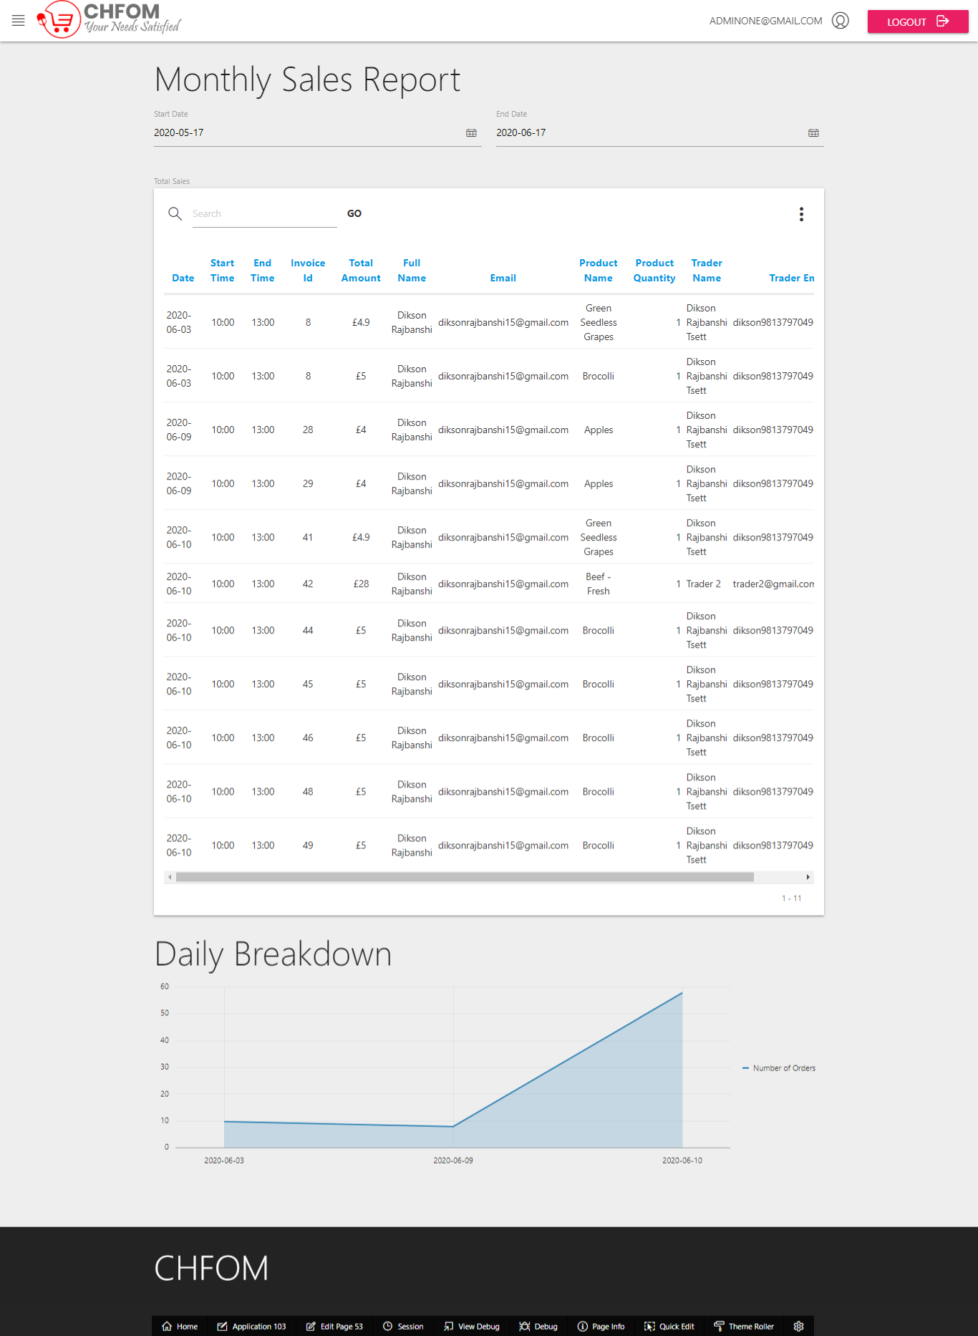

## View daily report on orders of all traders

Expected Result: A report with trader details and order details is shown

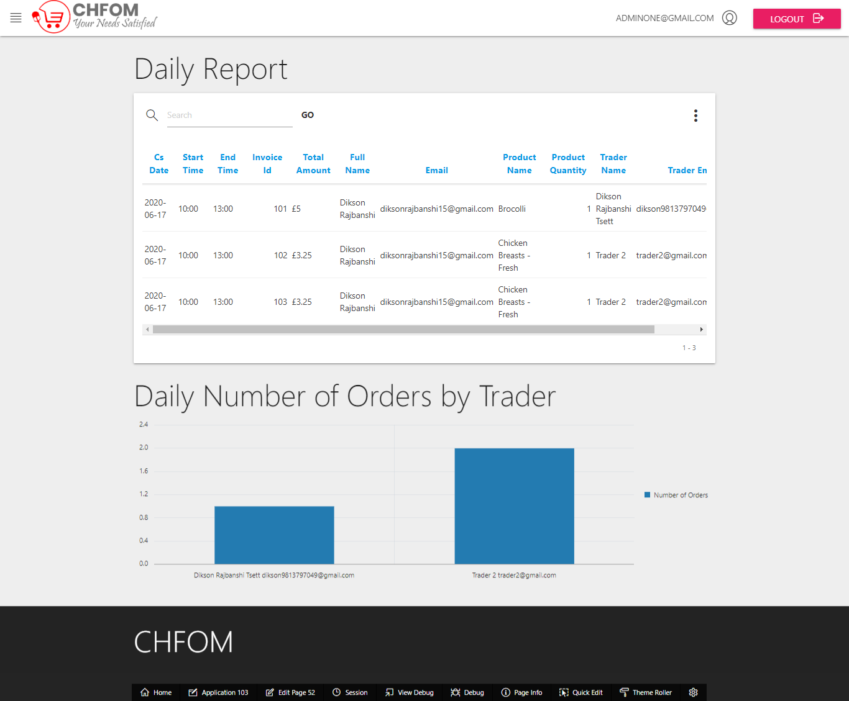

## View Reports

Expected Result: Admins can view monthly reports with editable date range